Document Image Reader
The purpose of this program is to identify sections of text in an image of a document for the eventual purpose of feeding each section into a text recognition (or OCR) program called “Tesseract”. This is useful, because Tesseract does not recognize column separations, nor does it output precise data regarding the location of text within a document. With the additional data generated by the program described in this document (along with some future development), we can more reliably do things such as:
- Get text in separate columns.
- Extract data from tables and/or bounding box.
- Determine the type of document, when the document is a generic document such as a tax return, paystub, a generic court order, a check, etc.
- Extract specific data about the content of a document that is a known type once the type of document is determined, such as whether any content exists in a signature section.
This program is very much a work in progress, and I haven’t been able to devote as much time to it as I would like, due to my work schedule. Still, I believe it represents the beginning of something that could be very useful to organizations that have to deal with a large volume of data contained in image files.
I will begin by giving a high level overview of how the program works, go over some the problems and limitations of the program in its current state, and conclude by giving some examples of test cases.

How it works
- Step 1: Get a binary edge detected image and fill in the contours.
  - Example image
    - Input and output

  - Having a binary edge detected image with filled in contours makes finding content sections a lot more straightforward, by giving us only two types of pixels to deal with: totally black and totally white.
- Step 2: Detect the skew of the document.
  - This is done by using Open CV’s implementation of the Probabilistic Hough Lines algorithm, and some basic statistics. The algorithm outputs a series of lines. I then calculate the angle of each line, record its left most Y coordinate, and then use linear regression to get an equation that will output a close approximation of the skew at any given point along the Y axis. This is necessary because the skew of a document image changes along the Y axis if a conventional camera is used to capture the image, as opposed to a scanner. Skew variance along the X axis has not been a significant issue thus far.
- Step 3: Detect the lines of text
  - This is accomplished by …
    - running scan lines through the document from top to bottom at regular intervals, and recording the lines that collide with a significant amount of white space in the binary image.
    - Once this is complete, the program finds gaps in the areas bounded by the top and bottom lines. If any given gap is greater than the height of the line of text, the program determines that this gap represents a column separation and splits the region into discrete sections.
- Step 4: Draw barriers around the content sections.
  - Example:

Known Issues
- In its current state, the program cannot deal with documents that have inconsistent vertical spacing between columns of text.
- The program combines lines of text with small fonts in a low resolution image. Practically, this isn’t much of a problem since Tesseract can read isolated block text fairly well.
- There is currently no support for identifying tables or bounding boxes on the document image. However, I don’t see this functionality being too difficult to implement.
- Performance is fairly slow. The situation can be significantly improved by scanning fewer points in the document, and/or using a lower level language to implement some of the more computationally intensive methods.

Test Cases

Test Case 1:
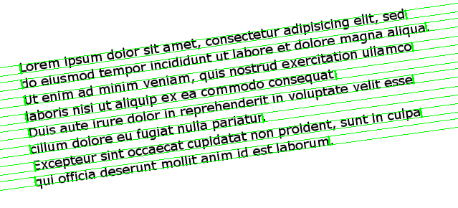
This is an example of a very easy image to deal with. The northward skew from east to west is near perfectly consistent across the entire document, and there is no noise whatsoever. Additionally, all the lines of text in the image can be found by using a line that’s left most coordinate is at X = 0 where Y >= 0 and Y < the height of the image. Note that Y = 0 at the top of the image and increases as one goes further south. This was the primary test case I used for my first release of the program on Github.

Test Cases 2 and 3:

These images are of the same document. One is skewed upwards from left to right; the other is skewed downwards from left to right. These cases differ from the first case in three important ways. I will list the three ways that these test cases differ, and elaborate on the implications of that difference in the bullet point below it.
- The document contains some noise
  - I dealt with this issue, by having a minimum threshold of white-space collisions that must occur, in a one pixel wide scan line, before that line is identified as the beginning of a content region. For example, suppose we have a line from (0, 100) to (400, 75). Suppose further that a white-space collision is found at point (137, 91), but nowhere else along the line, and that the minimum white-space collision threshold is greater than one. In this case, that scan line will not register as the beginning of a content region. This effectively deals with most instances of noise interference.
- Some lines of text in the image (toward the top and bottom) cannot be found by using a line that’s left most coordinate is at X = 0 where Y >= 0 and Y < the height of the image.
  - Notice that the bounding boxes around the lines of text toward the top and bottom of the image are missing part of the content. This is expected behavior. A perfect rectangle cannot be formed, that includes the text excluded from the bounding box if we limit the scope of the rectangle surrounding the region to coordinates that exist in the image. I considered capturing the text that the program misses by adding a white space triangle to the section that is eventually cropped out and passed to Tesseract, but ultimately decided it was not worth the time.
- The northward or southward skew from east to west is inconsistent across the Y axis.
  - I dealt with this by having the program take a linear regression of the east most Y coordinate, and the skew of each line found by Open CV’s implementation of the Probabilistic Hough Lines algorithm. The program then uses the (angle = (slope * left y coordinate) + intercept) equation generated by the linear regression and plugs the left Y coordinate of the scan line into the equation. The output is a close approximation of the skew angle at that point.

